Aireena Antony
DAF69 Batch

POWERBI – SUMMATIVE ASSESSMENT
- Data Cleaning and Loading
a) Import the dataset into Power BI using Power Query Editor.
b) Perform the necessary data cleaning steps to prepare it for analysis, including:
i) Handling missing values in columns.
ii) Removing duplicate rows.
iii) Standardizing the OrderDate column to a consistent date format.
c) Load the cleaned dataset into the Power BI model.

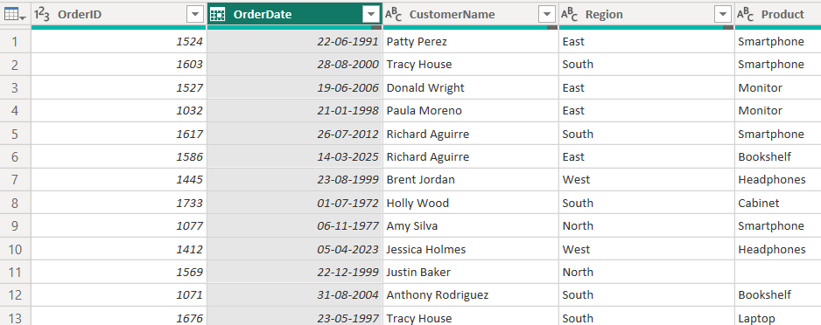

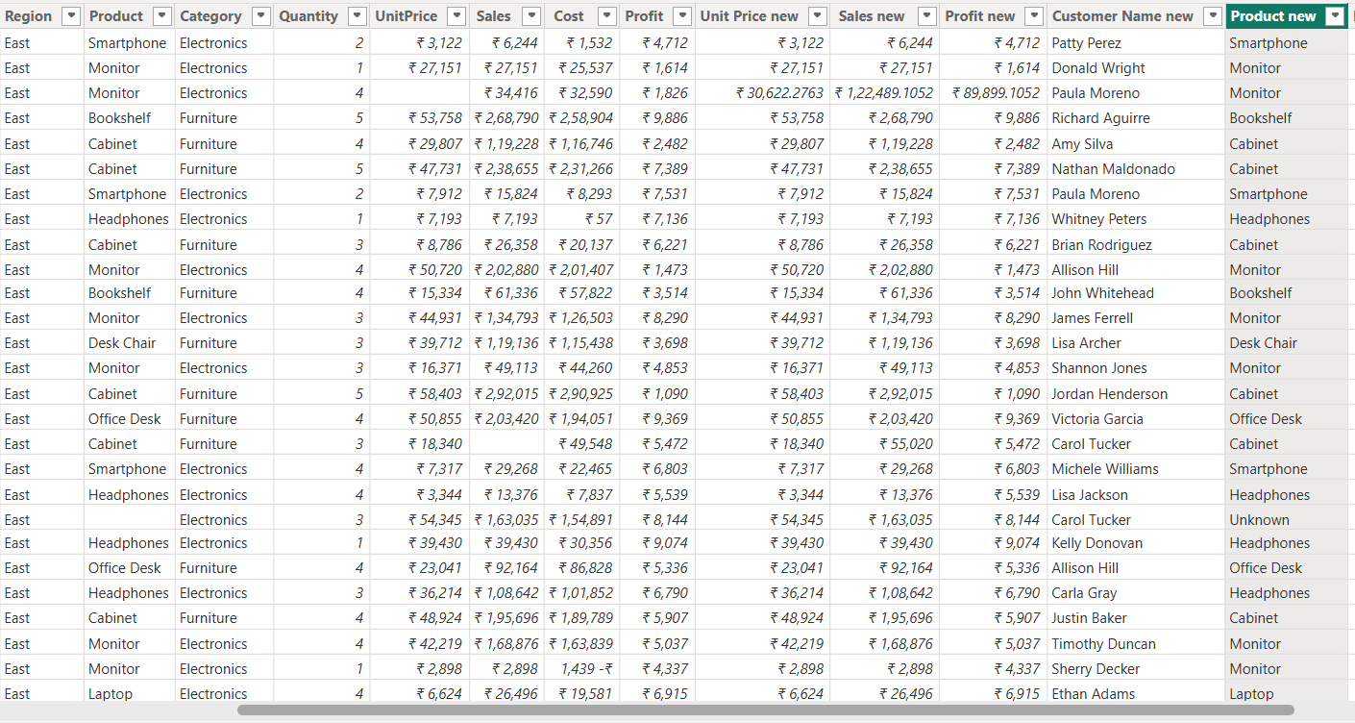

- Visualizations and Insights
a) Create a Pie Chart showing order distribution across different regions.
b) Create a Column Chart to display the top 5 trending products based on the number of times each product was ordered.
c) Create a Line Chart to show the profit trend over time.

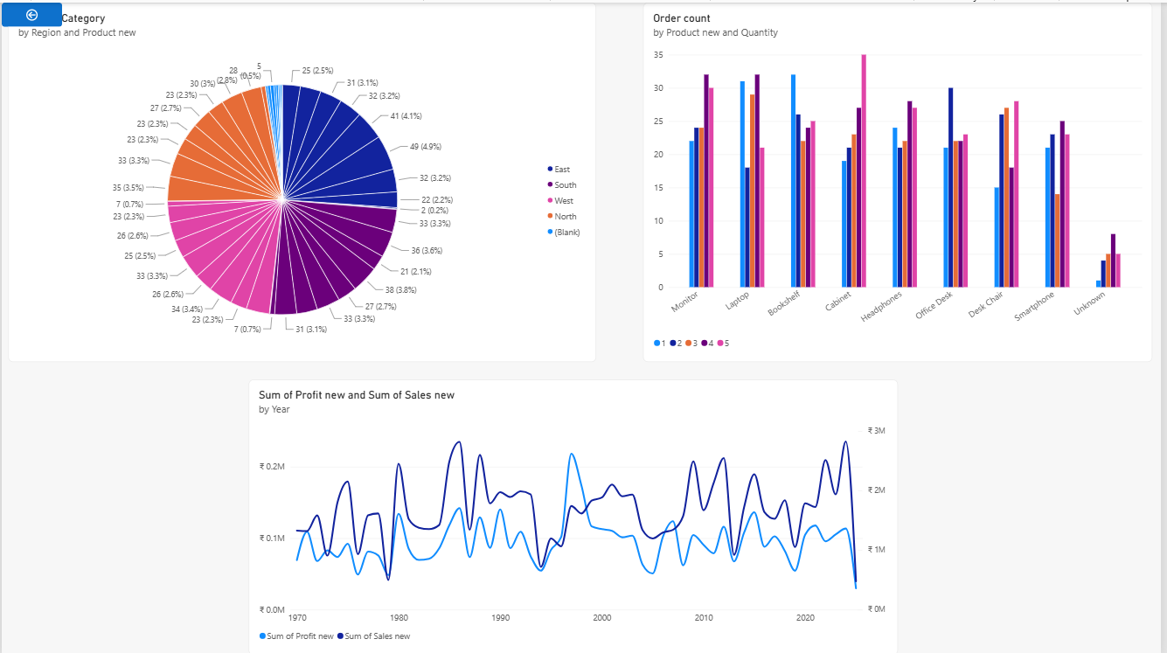

- DAX Calculations
a) Create a Calculated Table named EastRegionOrders that filters and displays only the orders from the East region.
b) Create a Calculated Column to compute the difference between the Profit and Cost columns. Name it ProfitCostDifference.
c) Create a Calculated Measure to find the total profit earned. Name it TotalProfit.

